DAY 5 TASK

GET methods

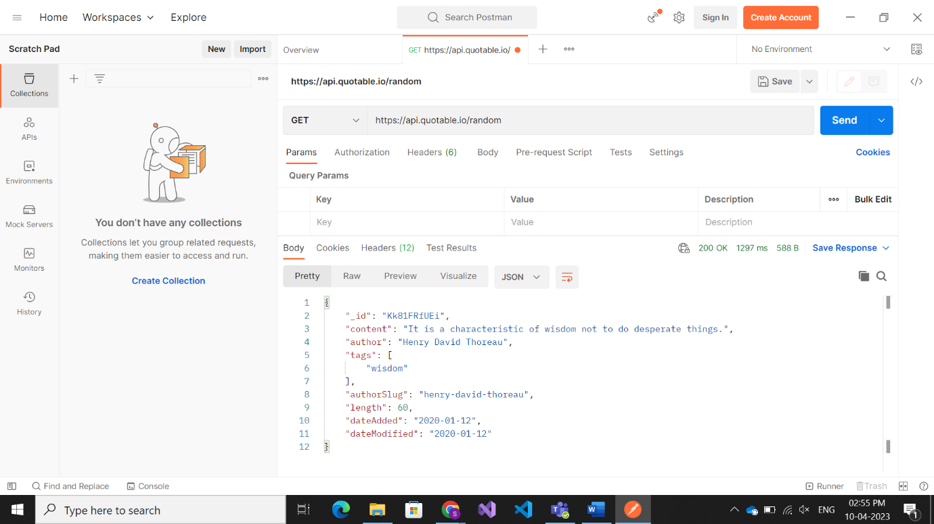

Post method

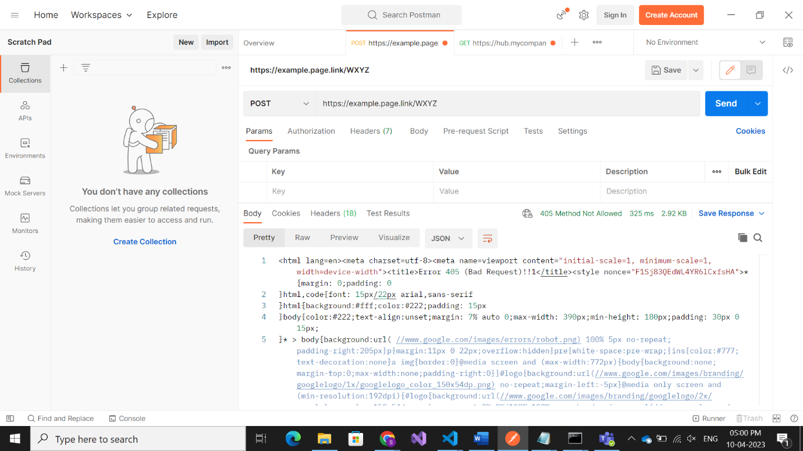

Put method

Patch method

